## Creating a new Test Suite

To create a new test suite, simply create a new Java class which extends AutomatedTestingSuite. Additionally you should add this class to the AllTestSuites class so that it can be included when all of the tests are ran.

## Creating a new Test

To create a new test, add a method to an existing test suite (any class which extends AutomatedTestingSuite). Import the @Test annotation first:

**import** org.junit.Test;

Then insert the the @Test annotation onto the new test method as shown here:

@Test

**public** **void** myNewTest() {

...

## }

This tells JUnit to include this method as a test and to report on whether it passed or failed.

## Running a Test Suite

You can run a single Test Suite by right clicking on its Java class, and selecting run as -> JUnit test.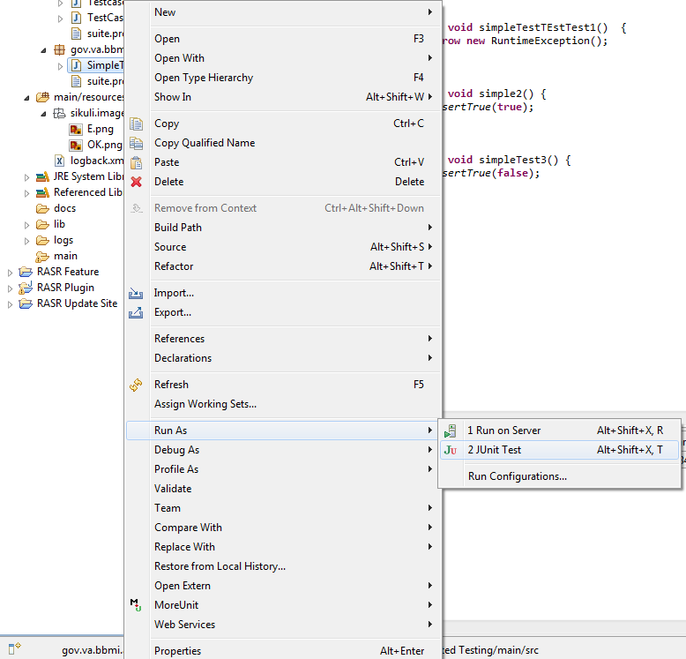

## Running all Test Suites

You can run all JUnit TestSuites by running the AllTestSuites class as a JUnit test (run as -> Junit test).

## Properties files

Suites can have and share a single properties file that is placed in the same directory as its java class.

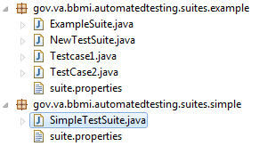

ExampleSuite will refer to suite.properties under the gov.va.bbmi.automatedtesting.suites.example package. The way to look up a property is to invoke the following code:

*driver*.get(getProperties().getProperty("URL"));

Calling getProperties().getProperty("URL") will return the “URL” property. This method is inherited from the AutomatedTestingSuite class.

## Results logging

Result logs are placed into the eclipse project folder under /logs. They are automatically generated whenever the JUnit test are ran.

## Transcript logging

It is the testers responsibility to manually log any selenium events such as click or wait. At least for now. Hopefully it will be possible to obtain one of selenium’s native loggers and force that to log all events. The AutomatedTestingSuite has a logger field that can be called by the child Testing Suite class:

**protected** Logger logger; //logger called by the tests manually

This is called from the child test method as follows:

logger.debug("Launch Firefox driver\n");

*driver*.get("http://158.147.211.128:8080/BBMI/");

logger.debug("Maximize Firefox window\n");

*driver*.manage().window().maximize();